**Reception Home Learning**

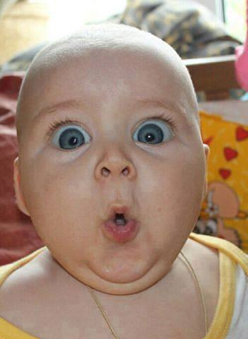

**3rd May 2018**

**Dear Parents and Carers,**

**Next week we will continue to learn about how human beings grow and what we need to keep healthy, such as food, exercise, sleep etc.**

**We will also think about the changes that happen as we develop from a baby to a child.**

**Please can you all send in a photo of your child as a baby.**

**We will be displaying these to play a ‘Guess Who’ game, so make sure they are named on the back of the photo only (and be as unrecognisable as possible to make it more tricky!).**

**These will be returned to you when we have finished the topic.**

**We will also be talking and writing about memories from when the children were babies. Please do share any funny or interesting anecdotes from when they were younger with your child this weekend so they can tell us about it in class.**

**Thank you and we look forward to seeing your lovely pictures.**