16th October 2017

Dear Year 6 Parents/Carers

Year 6 Residential: 2nd July – 6th July 2018

Thank you for paying the non–refundable £40 deposit in order to secure your child’s place on the Year 6 Residential Trip to Caythope PGL.

To settle the remaining balance of £270, you can either pay in full or alternatively in instalments as follows:

Friday 3rd November 2017 £67.50

Friday 9th February 2018 £67.50

Thursday 29th March 2018 £67.50

Monday 4th June 2018 £67.50 Final Payment

All payments should be made on Parentmail2. If this is not possible then cash/cheque payments will be accepted at the School Office and a receipt will be given.

Yours sincerely
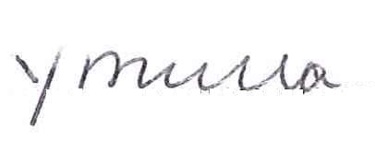
Mrs Y Mulla
Deputy Headteacher

